**Creating hierarchies**

In this demo, you create hierarchies. Hierarchies are groups of columns arranged in levels. For example, a Geography hierarchy might have sublevels for Country, State, County, and City. Hierarchies can appear separate from other columns in a reporting client application field list, making them easier for client users to navigate and include in a report.

To create hierarchies, use the model designer in Diagram View. Creating and managing hierarchies is not supported in Data View.

## **Creating Hierarchies**

#### To create a Category hierarchy in the DimProduct table

1. In the model designer (diagram view), right-click the **DimProduct** table > **Create Hierarchy**. A new hierarchy appears at the bottom of the table window. Rename the hierarchy **Category**.

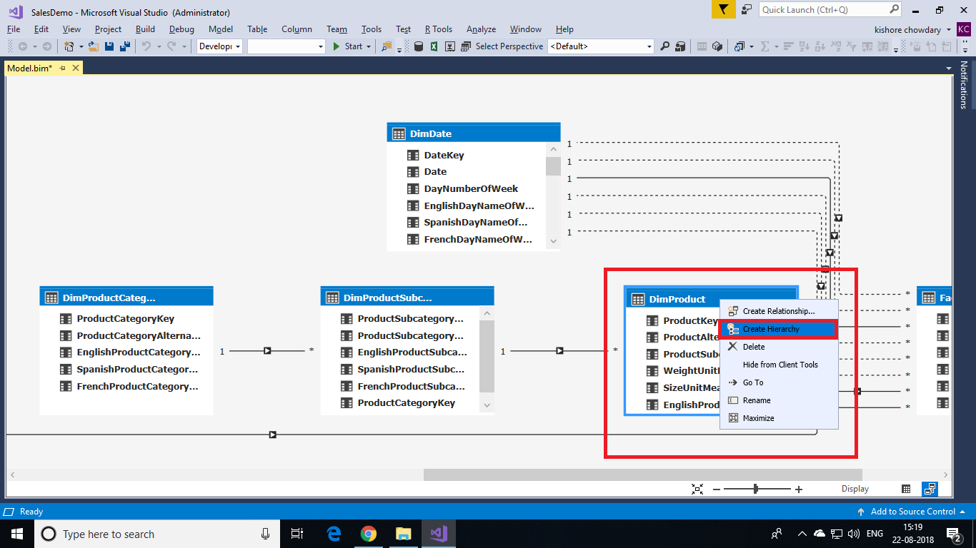

1. Click and drag the **ProductCategoryName** column to the new **Category** hierarchy.
2. In the **Category** hierarchy, right-click **ProductCategoryName** > **Rename**, and then type **Category**.

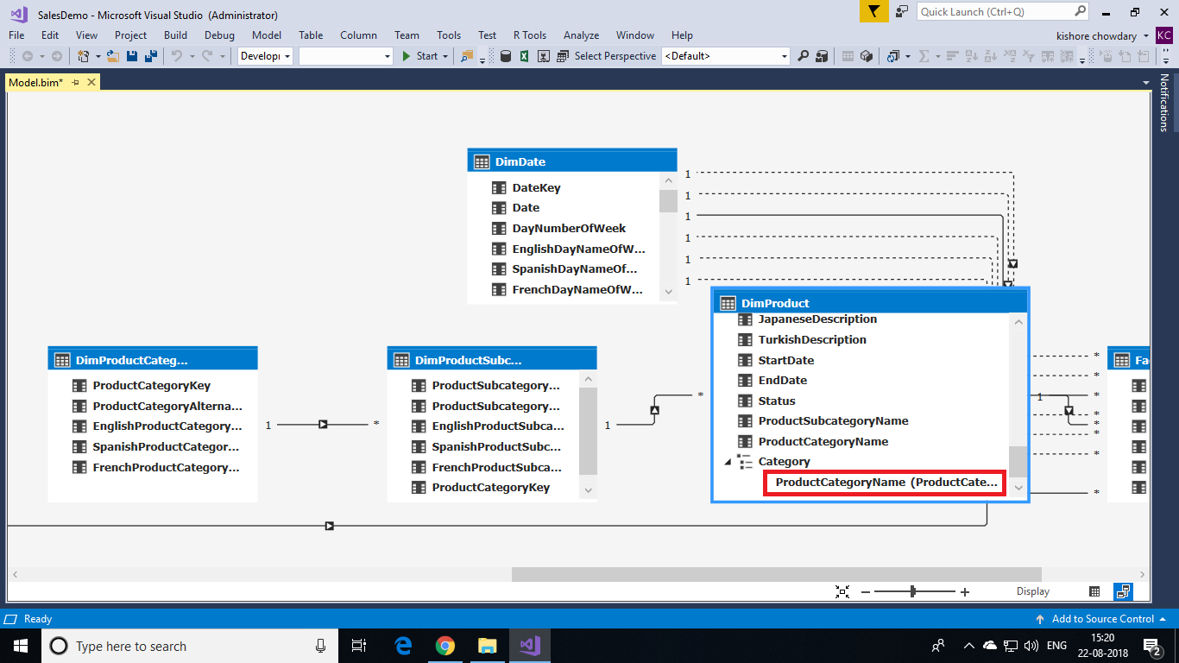

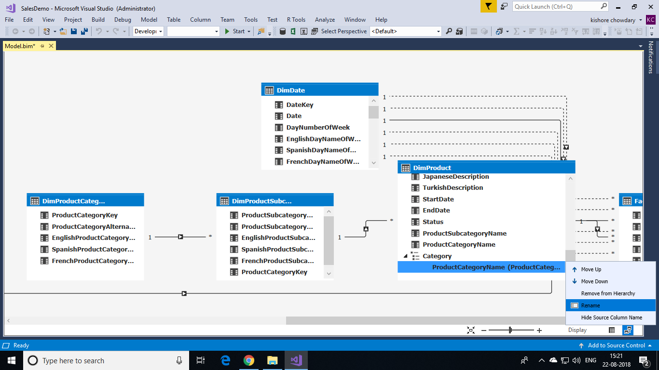

1. Click and drag the **ProductSubcategoryName** column to the **Category** hierarchy. Rename it **Subcategory**.
2. Right-click the **ModelName** column > **Add to hierarchy**, and then select **Category**. Rename it **Model**.
3. Finally, add **EnglishProductName** to the Category hierarchy. Rename it **Product**.

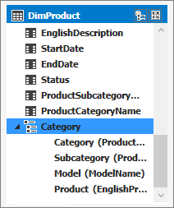

#### **Creating hierarchies in the DimDate table**

1. In the **DimDate** table, create a hierarchy named **Calendar**.
2. Add the following columns in-order:
   * CalendarYear
   * CalendarSemester
   * CalendarQuarter
   * MonthCalendar
   * DayNumberOfMonth

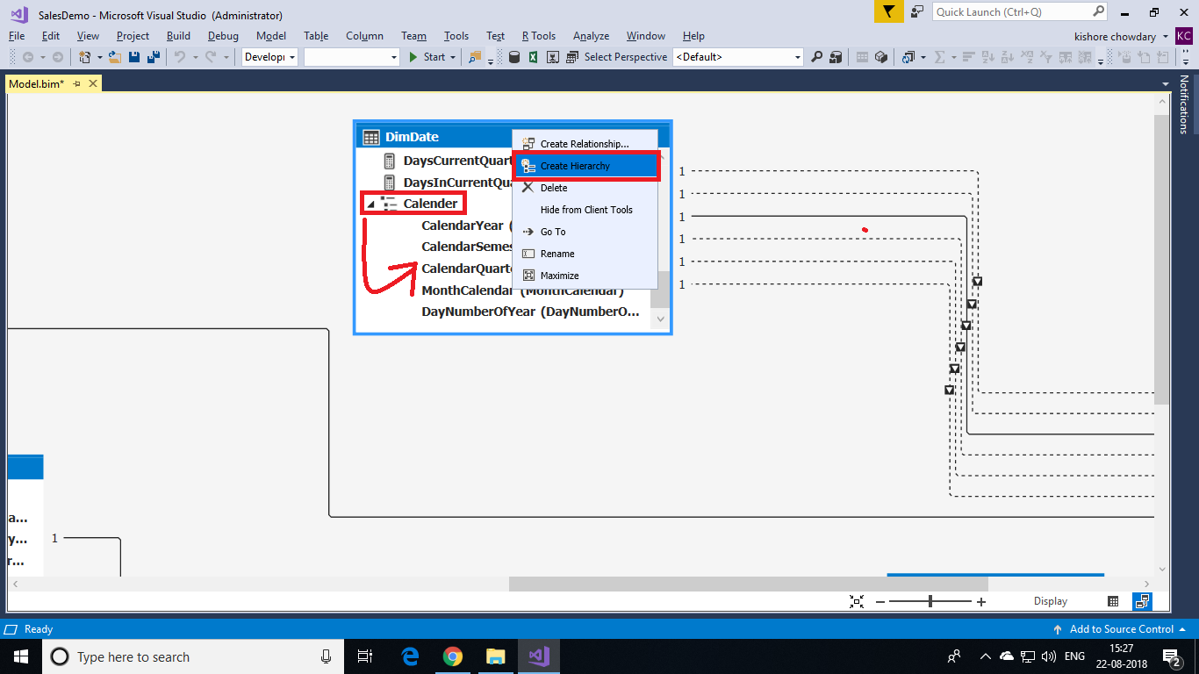

1. In the **DimDate** table, create a **Fiscal** hierarchy. Include the following columns in-order:
   * FiscalYear
   * FiscalSemester
   * FiscalQuarter
   * MonthCalendar
   * DayNumberOfMonth
2. Finally, in the **DimDate** table, create a **ProductionCalendar** hierarchy. Include the following columns in-order:
   * CalendarYear
   * WeekNumberOfYear
   * DayNumberOfWeek

